**SWIGGY ANALYSIS**

**STEP 1:**

**DATA TRANSFORMATION**

**First observed the project it bassically contains numerous data related to e-website and I had seen that it basically contains food delivery from dispatch to delivery**

**Step 2:**

**Here comes the cleaning part I used the following steps:**

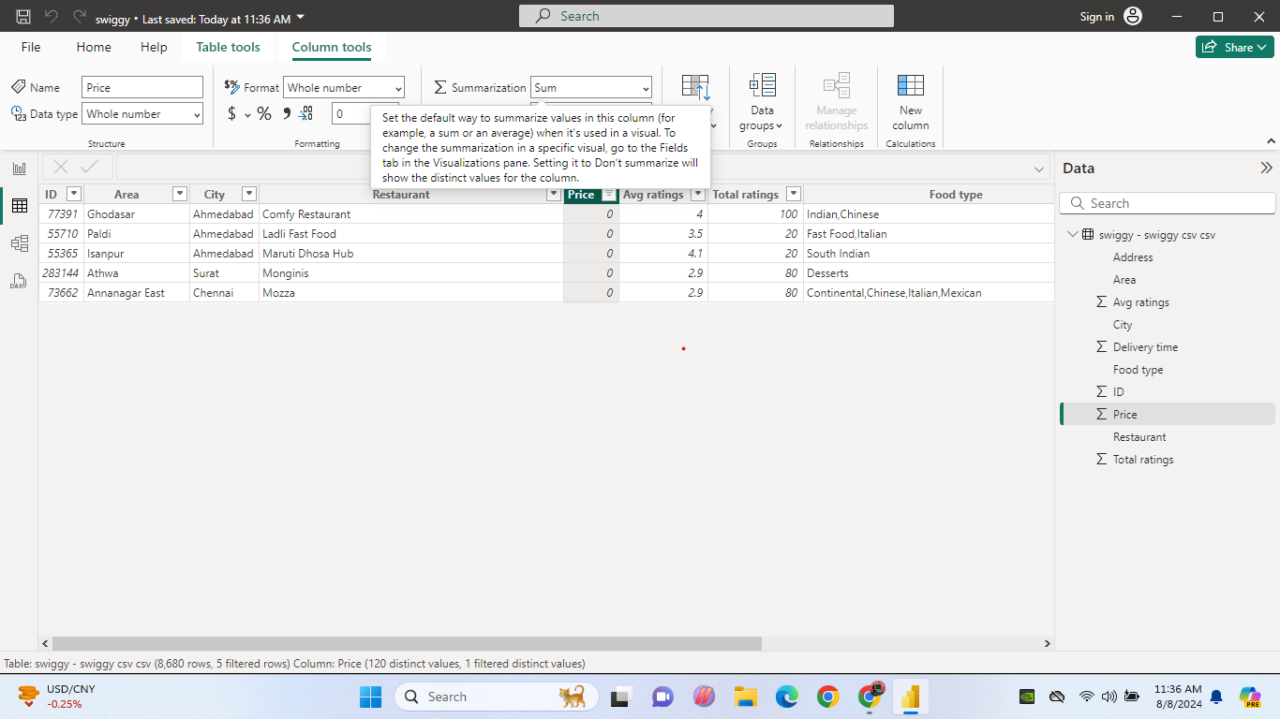 **I had seen that some of the prise values are zero so I decided to cut it down.**

**And then previously I had go through the task which were given and in task 3**

**Top rated swiggy restaurants in that task they particularly mention that above 4.5 so I decided to go conditional column option**

**Here I made new column based on the ratings**

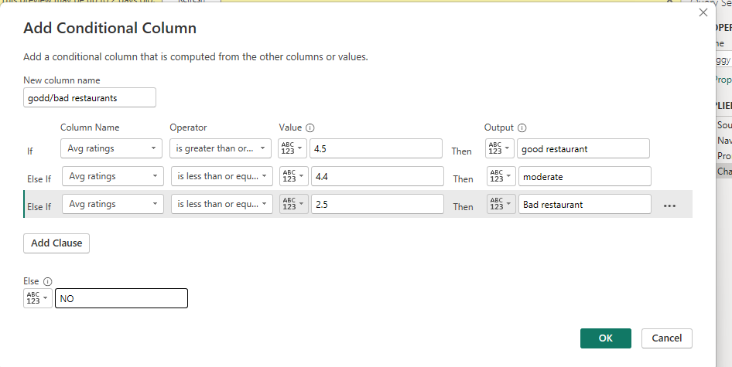

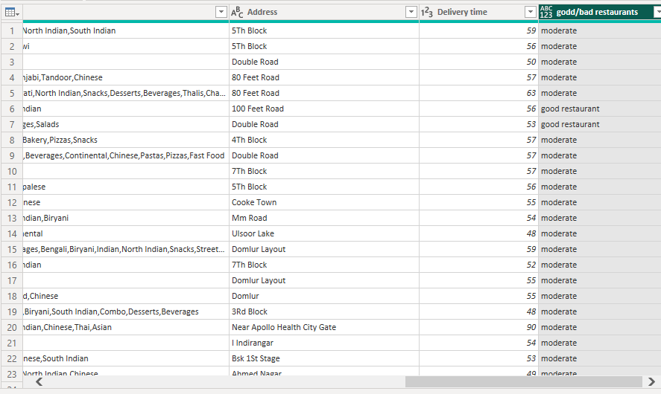

**Here comes the result by this I can make a report regarding the good bad moderate restaurants based on ratings in percentage.**

**Step 3:**

**Here comes the analysis part first I had so many confusions like where to start and how it will go and my presentation is going to be first and then I got some ideas and based on that I make analysis part are on following slides**

**TASK 1 : TOP 10 AREAS WITH MOST RESTAURANTS**

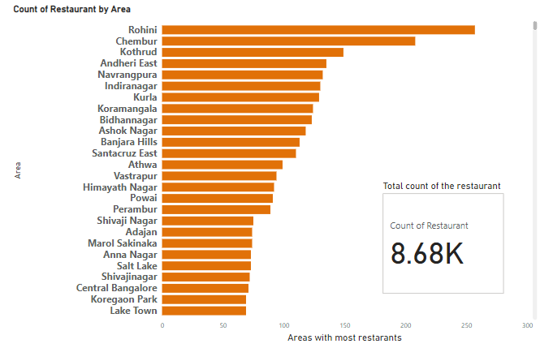

**AS my first task is to find top 10 areas with most restaurants here I found that**

**Top 10 areas with most restaurants**

**1.Rohini**

**2.Chembur**

**3.kothrud**

**4.Andheri East**

**5.Navrangpura**

**6.Indhira Nagar**

**7.Kurla**

**8.koramangala**

**9.Bindhannagar**

**10.Ashoak Nagar**

**One more thing I found on this particular report is the difference between the high count and less count is very distinct** 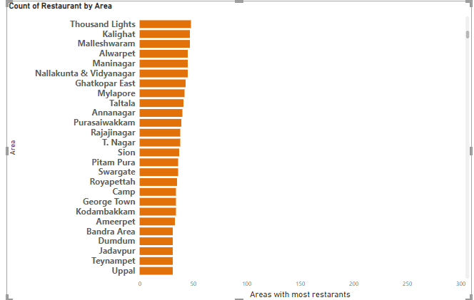

**CONCLUSION:**

**When we see down the line we can observe that the areas which have low count of restaurants is very low by this we can predict that service area is low or there needs to be a proper investigation in increasing the restaurants.**

**TASK 2: Most popular food types served by swiggy restaurants in each city:**

**Here I took count of the restaurants and cuisines they provide as by this we can know that what are the food types the restaurants preferred in each city can be concluded as popular food types.**

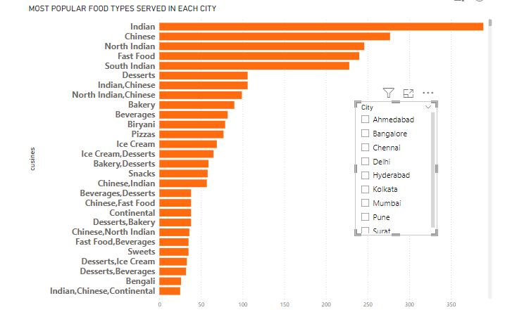

**By the way I here attached this screen shot how arrived the solution here below I mention the popular food types in each city basically the above image shows that there is a huge difference in first five food types and from 6 to rest so I took first two food types as popular food types.**

**1.Ahamadabad – Indian and north Indian**

**2.Bangalore – South Indian, Indian**

**3.Chennai- Indian, south Indian**

**4 Delhi- North Indian and Indian**

**5.Hydrabad – South Indian, Indian**

**6.kolkata – Indian and Chinese**

**7.Mumbai – Chinese, Indian**

**8.pune – Chinese, Indian, Fast food**

**9.surat – Fast food, Indian**

**CONCLUSION:**

**By this data I get some insights**

* **Dominance of Indian cuisines:** Indian cuisines, in its various forms is undoubtedly popular in all cities.
* **CHINESE CUISINES:** It is the second most popular in all cities.
* **REGIONAL SPECIALITIES**: Cities with Kolkata with Bengali cuisines and Hyderabad with Biriyani highlight the regional specialities.
* **FAST FOOD BEVERAGES:** Fast food and bakeryitems seems to be mostpreferable choices in each city**.**

**Task 3: Top rated swiggy restaurants :**

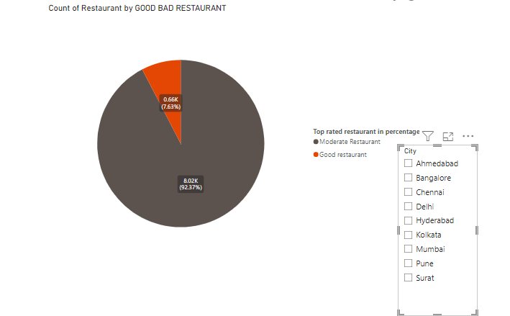

**CONCLUSION:**

* **From this task I come to that totally there are 7.63% restaurants rated 4.5 and I added a slicer with city to know about the which city has highest percentage and lowest high scorer is Chennai (10.85%) and Delhi (3.34%).**
* **As this data consist of limited good restaurants there is lack of people’s choices in swiggy as the rating is straight way from consumers.**

**TASK 4: CORELATION FACTORS AFFECTING AVERAGE RATING:**

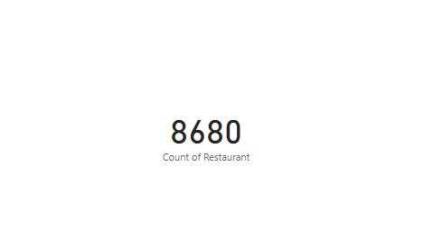

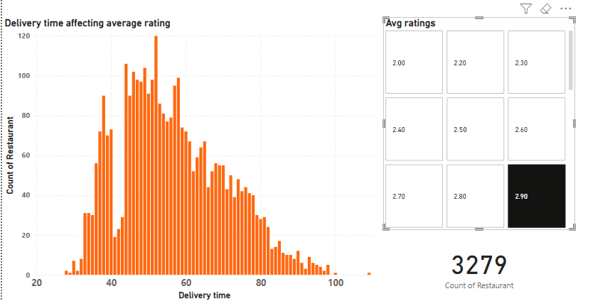

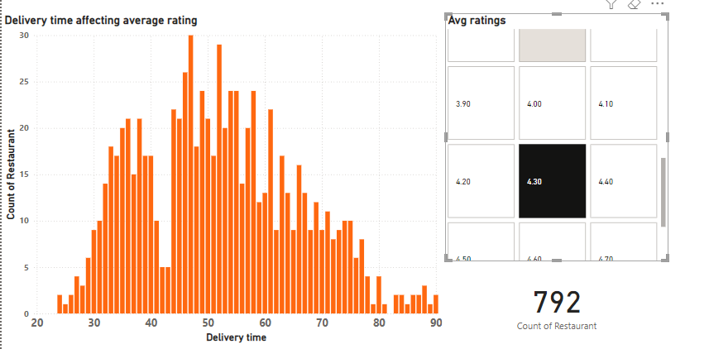

**By the above chart I compared 2 factors (delivery time, price) with Average rating and observed a jump count of the restaurant so I took 2.9 and 4.3 as two extremes one is positive and another negative**

* **I observed in 2.9: count of the restaurant is 3279**
* **In 4.3 : 792 restaurants are rated**

**By this we can see huge difference between these points and at 2.9 ratings the delivery time is gradually increases in 45 minutes and peaked at 1 hour.**

**By the way at 4.5 ratings there happened the same thing that is delivery time is between 45 minutes and 1 hour.**

**Conclusion:**

**BY this we can come to a conclusion that the people hate or they are not interested in too early and too late because of the food is not processed properly or the food is getting too late.**

**And we go with total rating and the chart were following:**

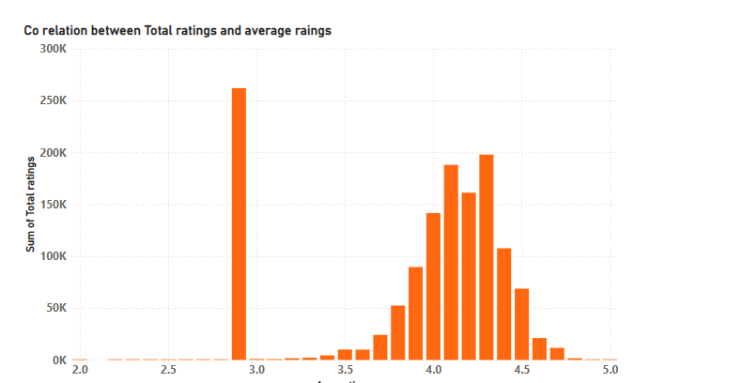**conclusion:**

**As we can see the above chart the average rating is peaked at 2.9 and at a gap from 3.5 it gradually increases and again peaked at 4.2 previously I said that I took 2.9 as disappointment and 4.0 is a healthy rewive and here also the same happened and by this I come to a conclusion that people hate is slightly high when compared to people like.**

**TASK 5 : CORELATION BETWEEN AVERAGE RATING AND RESTAURANT PRICE:**



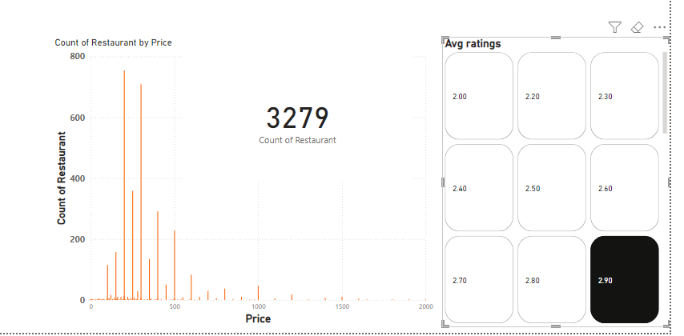

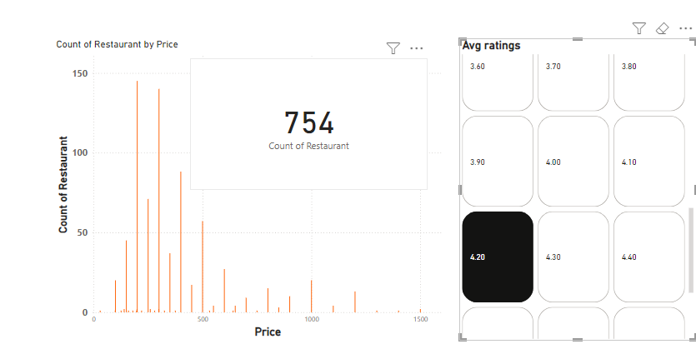

**Like the previous chart I make two points into consideration as it shows high low of the customer rating**

* **My 1 st point is 2.9 and the count is 3279.**
* **The highest point is 754.**

**CONCLUSION:**

**From this chart I understood that price range between 200 to 500 the rating happened when people rated 2.9 the price ranges between 200 to 500 so I cant say that the price is influencing the ratings because the price between 300 to 500 is an affordable one even though they got affected so they may be feels the food quantity or quality is less.**

**And the second picture shows that only less amount of restaurants are rated 4.2 compared to 2.9 and I can also observe that here in this chart the distribution of restaurant throughout the x axis is high when people rated 4.2 by this I can say that price not affecting that level when compared to delivery time.**

**TASK 6: CITY WISE RESTAURANT COUNT:**

**Here I used the pie chart to know the count of the restaurant by city wise**

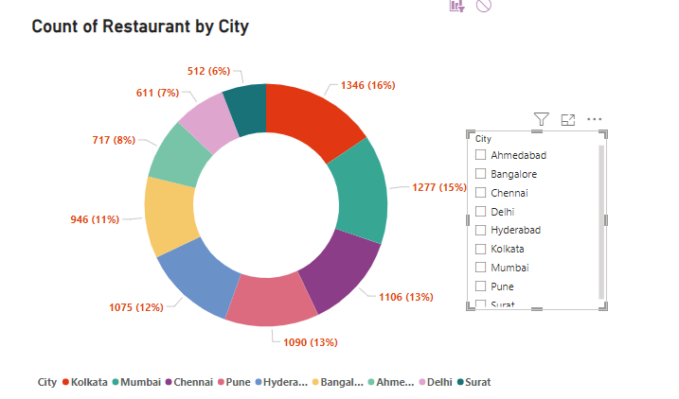

**As we can see the above chart it clearly says that an order**

**Restaurant order from highest to lowest**

* **Kolkata – 16%**
* **Mumbai -15%**
* **Chennai -13% (1006)**
* **Pune -13% (1090)**
* **Hyderabad - 12%**
* **Bangalore -11%**
* **Ahamadabad -8%**
* **Delhi – 7%**
* **Surat - 6%**

**CONCLUSION:**

**As eastern city (kolkata) has highest restaurant and and south eastern state (surat) has the lowest number of restaurants. The difference between the each city is not drastic one it had only slight difference.**

**There is a need in concentrating restaurants in southern states because least majority is southern and south eastern states.**

**TASK 7: PRICE ANALYSIS:**

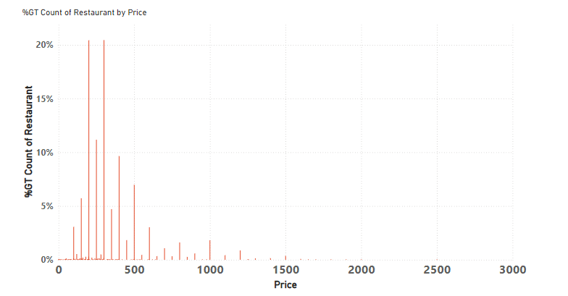 **The above chart clearly says that price distribution across the restaurants.**

**CONCLUSION:**

* **Concentration in low price range: The vast majority of restaurants are clustered in the lower price range (0-500) indicating a strong preference for budget- friendly options.**
* **Rapid decline: The number of restaurants decreases rapidly as the price increases. It indicates that there is a need in increasing concentration on these areas.**

**TASK 8: DELIVERY TIME ANALYSIS:**

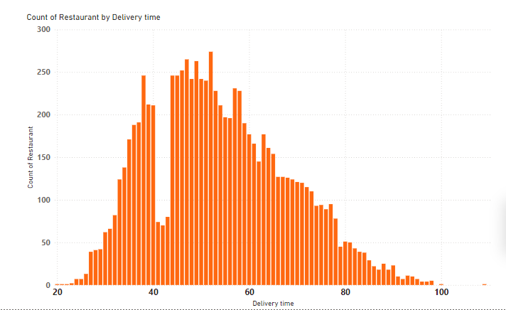

**CONCLUSION:**

**PEAK DELIVERY TIME: The chart shows a clear peak in the number of restaurants around the 50 minutes delivery time mark. This suggest that a**

**significant number of restaurants target a delivery time of approximately 50 minutes.**

**TASK 9: CUISINE ANALYSIS:**

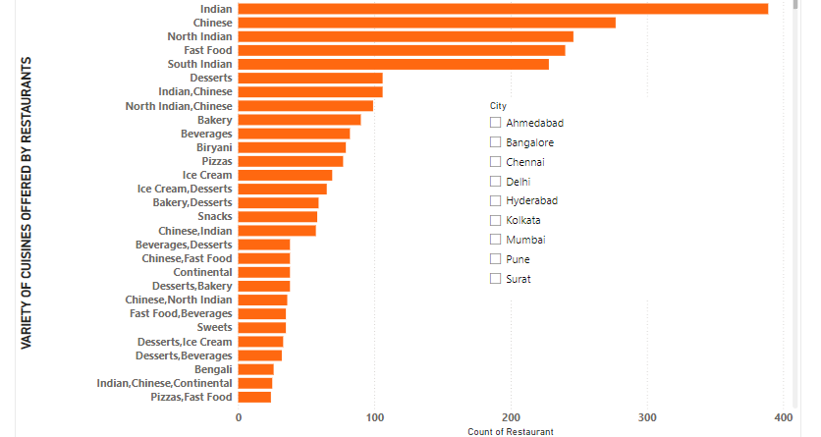

**The above chart is to analyse the cuisines offered by the restaurants**

**CONCLUSION:**

**The above chart I can observe that the regional cuisines like South Indian and North Indian are taking a dominance position and it denotes that need to concentrate on the other cuisines.**

**TASK 10: AREA-WISE RESTAURANT ANALYSIS:**

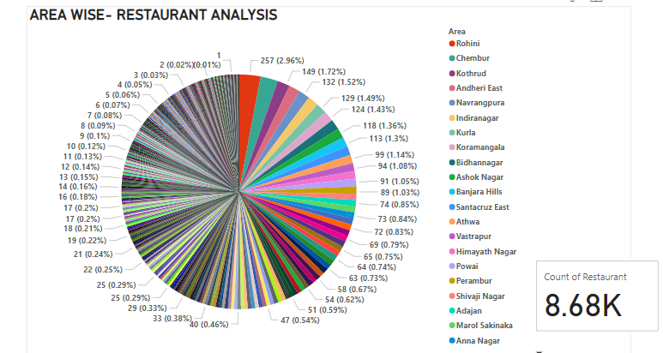

**BY the above chart I can get areas with high number of restaurants in percentages**

**CONCLUSION:**

**DOMINANT AREAS: Areas like rohini, chembur, kothrud have higher number of restaurants compared to other regions. These areas might be commercial hubs or have large population base.**

**Task 11: CO-RELATION ANALYSIS:**

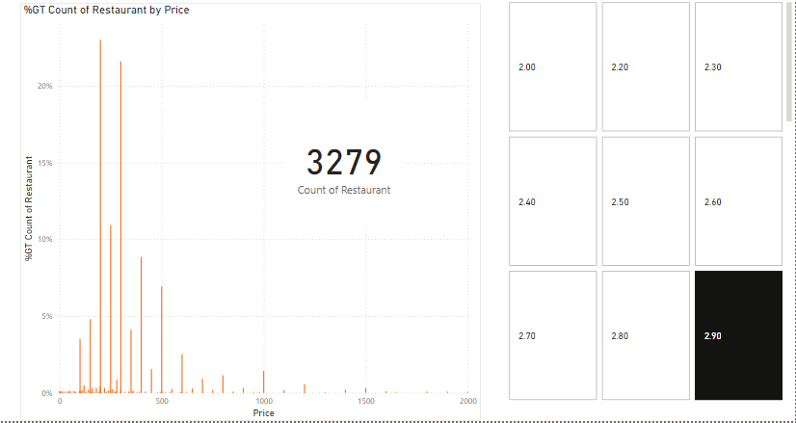

**As a sample I took 2.9 as negative rating and the 3279 restaurant received 2.9 rating which is huge from 8000 restaurants which is half of the restaurants customers are expected the price should be l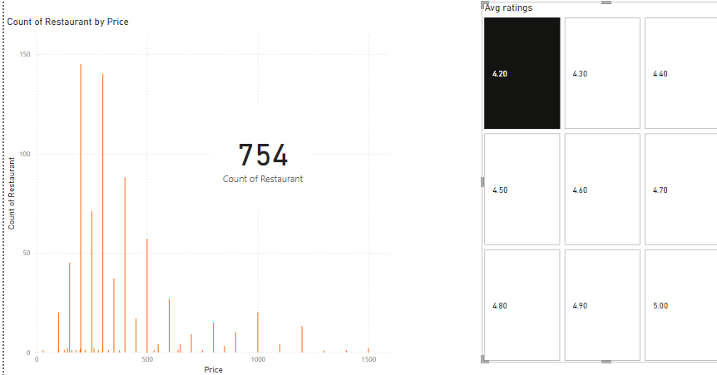 Here the 4.2 is best rating but relatively low so people expect the price should be low**

**Comparision of delivery time with Average rating:**

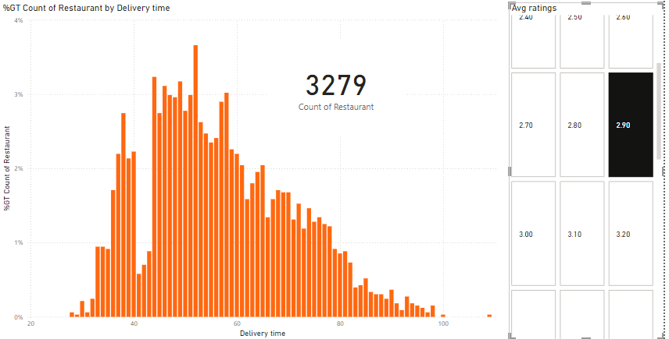

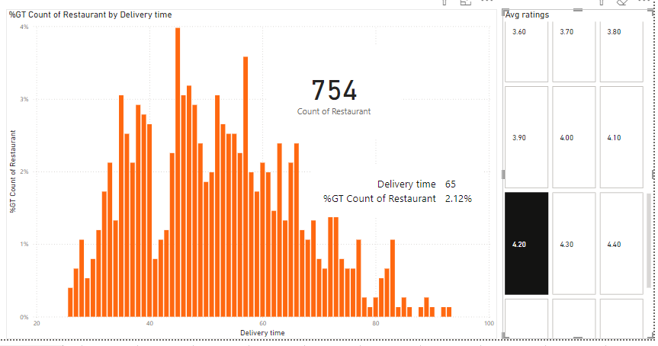

**Conclusion:**

**The above chart clearly says that average rating 2.9 the restaurant count is very high by I can say that the delivery is not happened on time as expected by the customers half of the hotels received negative rating. And the we come to 4.2 the restaurant is less so there is need to analyze the perfect delivery time to increase the average rating.**

**TASK 12 : CUSTOMER FEEDBACK ANALYSIS:**

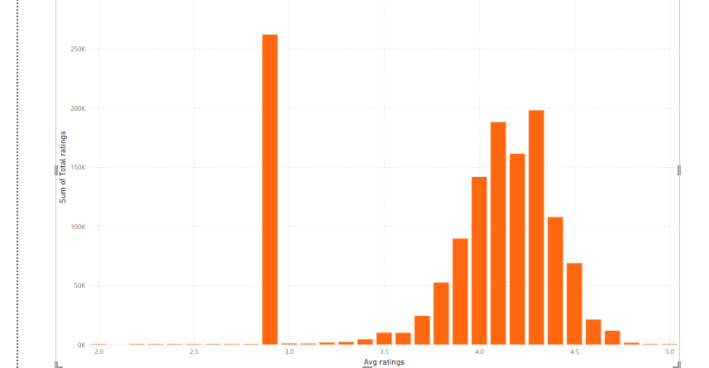

**Customer feedback can be analysed by comparing average rating with total rating as the above chart shows that the graph peaked at 2.9 as we see previous task the negative ratings are basically on 2.9 so by this we can say that the people felt bad at many occasions and we can also see some of the moderate ratings (3.5-4.3) this cannot be accurate because the people with no opinion also can give these ratings so as the second largest is these moderate areas .**

**And as we all know that the above 4.5 can be considered as best ratings sadly it has very low by this data we can say that the people’s will to swiggy is low or moderate .**

**TASK 13 : GEOGRAPHICAL MAPPING:**

**AS THE GIVEN DATA HAS NO PROPER COORDINATES (LATITUDE AND LONGITUDE) SO I CANT LOCATE THE PLACES EXACTLY SO I SKIP THE TASK 13**

**TASK 14: BUSSINESS RECOMMENDATION:**

**Based on the above data charts I can conclude some thinks and based on that I give the recommendations are as follows:**

* **The dense of the restaurants in some areas is huge and some areas is very few so there is a need in increasing the restaurants in many areas based on the population of that particular area.**
* **The food types preferred by swiggy is only regional food types it indicates that there is a lack of promotion in other food types and there is a need in promotion of other cuisines.**
* **The high Average ratings (4.5) given to the restaurants is only 10% so there is lack of best service it can be due to lack of delivery time, food quality so the choice of the restaurant and delivery agent should be good.**
* **We can see some cities like Surat , Delhi have less number of restaurants so there is a need in increasing service area through these states.**
* **As we come to price the restaurants providing foods in budget friendly options but there is a lack of distribution of restaurants in high price range the so it can be helpful in increasing the business value and it is also a pathway to reach elite customers.**
* **Delivery time is peaked at 45 minutes to 1 hour and people give good rating at this time but there is 30% of the restaurants are still giving more than this time so the availability of delivery agents should be increased**
* **Total rating given is peaked at 2.9 it indicates the people felt bad about the service so this should be taken into account and it indicates the company needs to take care of all aspects to increase the rating.**

**THANK YOU**